Indonesian Journal on Geoscience Vol. 7 No. 1 April 2020: 15-24
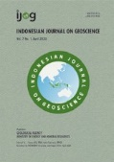
INDONESIAN JOURNAL ON GEOSCIENCE
Geological Agency Ministry of Energy and Mineral Resources
Journal homepage: hvp://ijog.geologi.esdm.go.id ISSN 2355-9314, e-ISSN 2355-9306

Nannofossil Distribution and Age of Kendeng Zone In Kalibeng River Section of Kedungringin, Plandaan Area, Jombang, East Java

Siti Umiyatun Choiriah , Carolus Prasetyadi , Rubiyanto Kapid , and Dwi Fitri Yudiantoro
1 1 2 1

¹Geological Engineering, Faculty of Mineral Technology UPN “Veteran” Yogyakarta, Indonesia Jln. SWK 104, Condongcatur, Kabupaten Sleman, Daerah Istimewa Yogyakarta
2
Geological Engineering, Faculty of Earth Sciences and Technology, Bandung Institute of Technology (ITB) Jln. Ganesha No. 10, Bandung, Indonesia

Corresponding author: sumiyatunch@upnyk.ac.id; umiyatunch@yahoo.com Manuscript received: October, 20, 2016; revised: December, 19, 2016;
IJOG
approved: September, 05, 2019; available online: January, 21, 2020

Abstract - This study was carried out at Kalibeng River Section, in Kedungringin area, a site with lithology suitable for a nannoplankton research. Methods used in this research include performing a stratigraphical measurement section at the field, collecting thirty-two samples, and preparing the samples with the smear slide method using a polarizing microscope with 1000x magnification, and preparing several rock samples using SEM analysis. The analysis of nannofossil resulted in twelve genera and forty-three species. The identified genera are: Calcidiscus, Coccolithus, Ceratolithus, Discoaster, Gephyrocapsa, Helicosphaera, Pseudoemiliania, Reticulofenestra, Rhabdosphaera, Sphe- nolithus, Syracosphaera, and Umbilicosphaera. The presence of these genera indicates that Kalibeng River Section have abundant nannofossils and based on the nannofossil analysis, from older to younger, the studied stratigraphic sequence indicates a more detailed age determination as follows: the Marl Unit of Kalibeng is NN10-NN18 (Middle Miocene to Pliocene), Calcareous Sandstone Unit of Sonde is NN19-NN20 (Pliocene-Pleistocene), and Calcareous Claystone Unit of Sonde is NN20-NN21 (Pleistocene).
Keywords: calcareous fine clastics, nannoplankton, Miocene to Pleistocene, Kendeng
© IJOG - 2020. All right reserved

How to cite this article:
Choiriah, S.U., Prasetyadi, C., Kapid, R., and Yudiantoro, D.F., 2020. Nannofossil Distribution and Age of Kendeng Zone In Kalibeng River Section of Kedungringin, Plandaan Area, Jombang, East Java Data. Indonesian Journal on Geoscience, 7 (1), p.15-24. DOI: 10.17014/ijog.7.1.15-24

Background
Introduction
reconstruction of paleobiogeographic (Van Gor- sel et al., 2014).
The stratigraphic analysis shows that the

Research of fossil is one of the most impor- tant tools for the study of sedimentary rocks and basins. First, the succession of evolution- ary appearances and extinctions provides age control, which is critical for understanding basin evolution and validation of geological concepts. Second, fossils are useful for interpretation of local paleoenvironment, paleoclimate, and also
Kendeng Zone is a young fold-thrust belt, which was only active within the Pliocene. In this zone, deep marine volcaniclastic sediments of Early Pliocene and older ages have been uplifted and thrusted northwards since mid-Pliocene time (Lunt, 2013, in Berghuis et al., 2019).
The Kendeng Zone is the southern part of East Java basinal system. The sedimentary evolution

Accredited by: RISTEKDIKTI (1st grade), valid August 2016 - April 2020 Indexed by: SCOPUS (Q3)

of this basin indicates that the East Java basinal system was formed as a continuation of extension around the Makassar Strait to the east, and not as a back-arc basin. This interpretation is based on tectonically pulsed east to west trend in crustal thinning, subsidence, and trans-gression (Lunt, 2019)
The studied area is occupied by a sedimenta- tion sequence consisting mostly of fine-grained marine sedimentary rocks that contain abundant microfossils with the age from Miocene to Qua- ternary. A nannoplankton research in the Kendeng Zone has been done by Choiriah et al. (2001), but only limited to the Bengawan Solo River in Ngawi. The results of previous study in Ngawi section show that the nannofossil contained within Kalibeng Formation consists of eighteen genera and forty-nine species, while Klitik/ Sonde Formation has eight genuses and twelve species. The age of Kalibeng Formation is Late Miocene to Late Pliocene (NN12-NN18), and Klitik (Sonde) Formation is of Early Pleistocene (NN19-NN20)
IJOG
The purpose of this study is to determine the distribution and the age of the youngest marine sediments in Kendeng Zone based on nannofossil found in the Kalibeng River Section, and to cor- relate it to the similar result of the Ngawi Section.

Stratigraphic Setting
The studied area, which is part of Kalibeng River in the Kedungringin and surrounding area, Plandaan Subregency, Jombang, East Java, is situated in the Kendeng Zone. This part of the river is classified as the type locality of Kalibeng Formation since it is located in the Kalibeng River. According to Pringgoprawiro (1983), the order of the lithostratigraphic formations in the Kendeng Zone, from the oldest to the youngest is as follows: Pelang Formation (Tomp), composed of marl and claystone with intercalation of calcarenite; Kerek Formation (Tmk), comprising interbedded marl, limestone, and sandstone; Kalibeng Formation (Tmpkk), consisting of marl with intercalations of sandstone {with Atasangin Member (Tmpa) made up of breccia, sandstone, and claystone}; Sonde Formation (Tpso), composed of marl, calcareous

claystone, tuff, and sandstone {with Klitik Mem- ber (Tpk) consisting of limestone}; Pucangan Formation (Qtp), composed of tuffaceous breccia, conglomerate, and tuffaceous Sandstone; Kabuh Formation (Qpk), consisting of coarse tuffaceous sandstone with cross-bedding sedimentary struc- ture, claystone, and conglomerate; and Notopuro Formation (Qpn), comprising tuff, interbedded with tuffaceous sandstone, volcanic breccia, and conglomerate (Figure 1).
Sedimentary rocks found in the studied area contain a large amount of microfossils, including nannoplankton which is very valuable to support the objective of this study. Nannofossil is a kind of algae which belongs to the Haptophyceae class with a tiny size (0.5-10 µm). In the living state, this organism has planktonic characteristics.

Materials And Methods

Field Data Sampling
This step consists of making a measurement section and detailed rock sampling to better understand the changing and development of nannoplankton, as well as determining the age of each rock layer (Figure 2).
A large amount of nannofossils was collected from a small sample due to its tiny size. Rock samples that contain the fossils can be obtained from outcrop, drill core, or cutting.

Laboratory Analysis
Equipments needed for the analysis include rock sample, prepared slides, coverglass, grinder, dryer/oven, weter, pipette, entellan liquid (func- tions as glue), and labels.
Nannoplankton is very small to identy mac- roscopically, that is why an optical (polarizing) microscope with a high magnification (1000 X), or even Scanning Electron Microscope (SEM) is needed. The nannofossil analysis was performed using a polarizing microscope by making “smear slides” that could be prepared in a few minutes. The nannofossil analysis was done using a polarizing microscope with 1000x magnifica- tion, in parallel and cross Nicol views. The

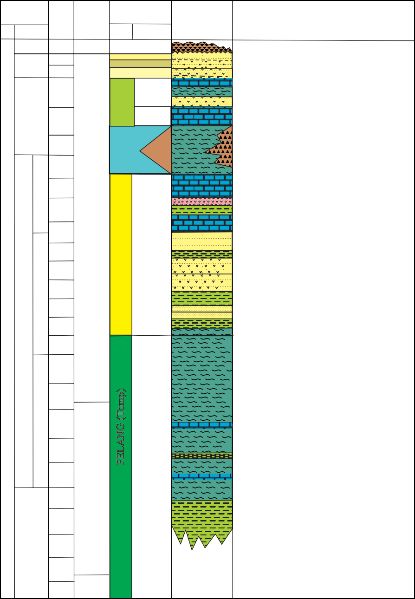
Figure 1. Stratigraphy of Kendeng Zone (modified after Pringgoprawiro, 1983).
NOTOPURO (Qpn)
KABUH (Qpk)

PUCANGAN (Qtp)
P14
Tcd
P9
P20 (N1)
P21 (N2)
P22 (N3)
N4
N5
N6
Lower
Te
N7
N8
N9
N10
N11
N12
N13
N14

N15
N16
N17
N18
N19

ATAS ANGIN
(Tmpa)
KLITIK
(Tpk)

N20

N21

PLIOCENE

N22
Lower
Tf
Middle
Upper
N23
PLEISTOCENE
Marl and claystone with calcarenite intercalation of calcarenite with larger foraminifera
Laharic breccia, tuff, tuffaceous sandstone; ﬂuviatile cross-bedded sandstone.
Volcanic conglomerate, sandstone, black claystone Marl, calcareous claystone, tuff,
sandstone with Balanus and mollusca

Corraline limestone, bedded Globigerina limestone

Massive Globigerina marl with intercalations of graded sandstone, volcanic breccia, and tuff

Hard calcarenite, bedded calcarenite, tuff, calcirudite

Tuff and agglomerate Hard calcarenite

Interbedded marl, claystone, and mudstone
TRINIL
HOLOCENE
25
20
20
10
0,5

2
MEMBER
FM

DESCRIPTION

LITHOLOGY

STRATIGRAPHY
ADAM (1970)

AGE
OLIGOCENE
IJOG

photomicrographs of fossils were taken using a microscopic camera (Moticam) connected to a laptop or computer. The names of genus and spe- cies were referenced from previous researchers (Martini, 1971; Okada and Bukry, 1980; Perch- Nielsen, 1985; Aubry, 1985). The appearance of nannofossil species in each rock sample is the main data of this study.
MIOCENE
Middle
Early
Late
BLOW ZONATION (1969)
SONDE
(Tpso)
PELANG (Tomp)
KEREK (Tmk)
KALIBENG (
(Tmpkk)
The photomicrographs of nannofossils within
the researched area were taken using a polarizing
microscope in Petrographic Laboratory UPN “Veteran” Yogyakarta and Scanning Electron. Microscope of Sedimentology Laboratory, ITB.

Result and Analysis

Stratigraphically, the Kalibeng River Section in the studied area is composed of Marl Unit of Kalibeng Formation, Calcareous Sandstone Unit

19
D-24

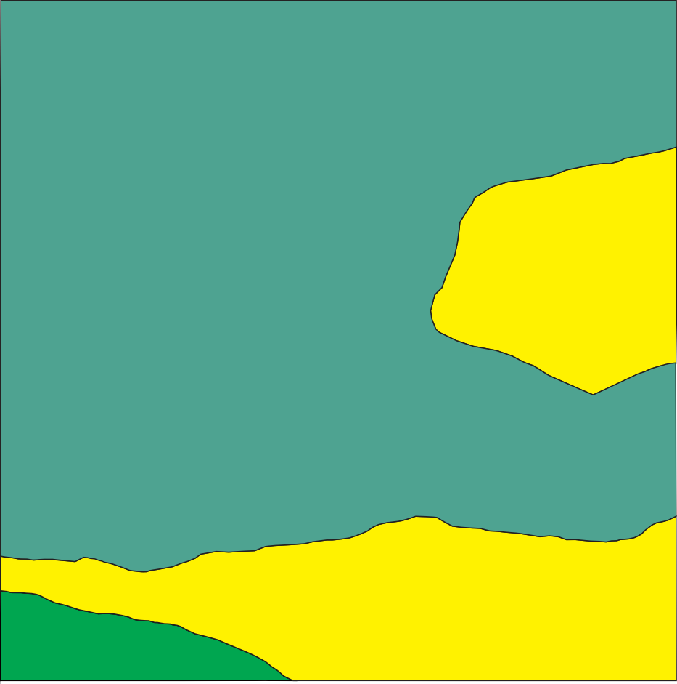
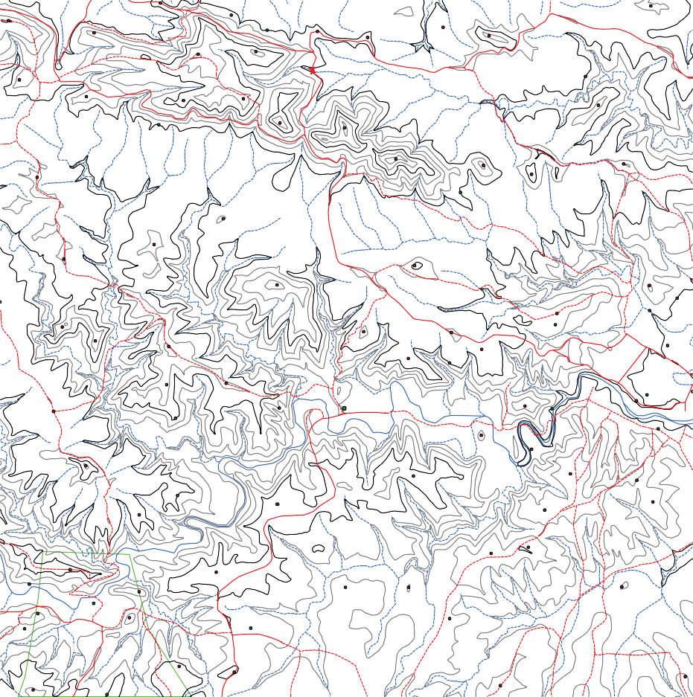
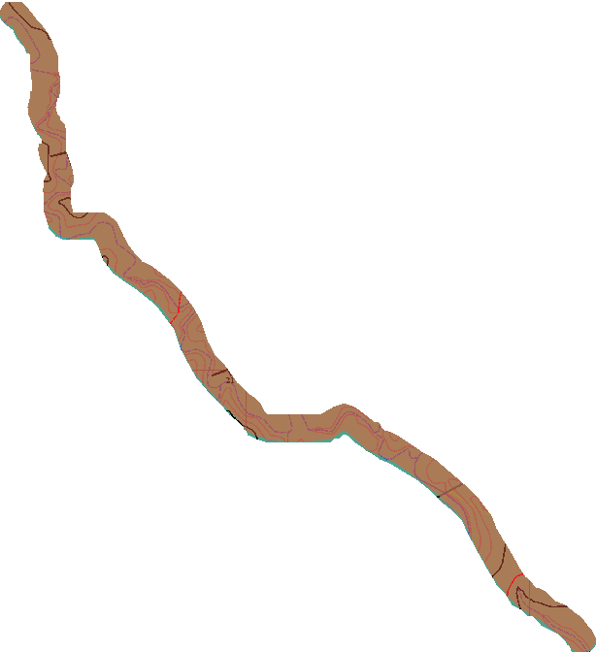
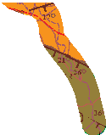
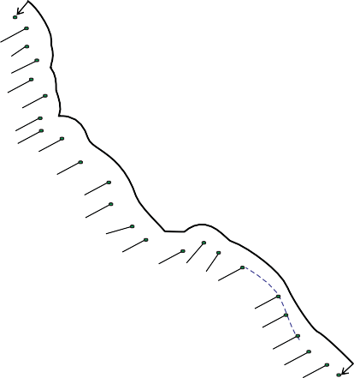
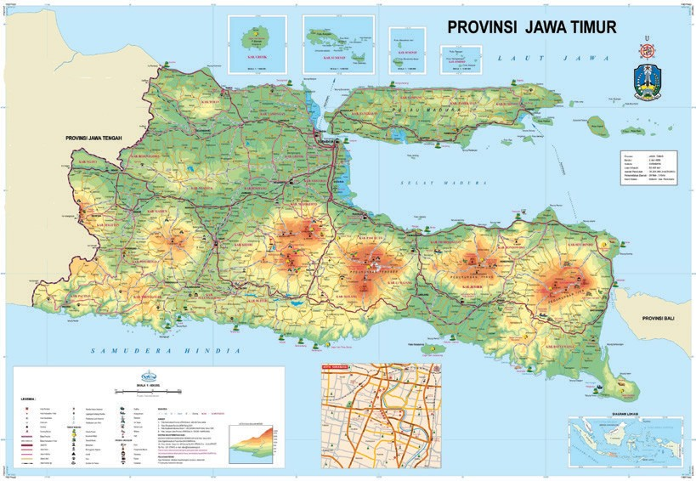
Figure 2. Location of calcareous sediment sampling for the nannoplankton analysis within the background of the geological map of Kedungringin area.
620000.000000
621000 .000000
622000.000000
623000.000000
624000.000000
156.73
KABUPATEN JOMBANG
201.8
134.04
181.01
154.78
N
168.52
0
500
171.99
100
1.000
Meters
171.71
207.88
219.66
115.51
150
230.3
230.63
137.3
142.63
150
10
D-1
Klitih
126.81
134.33
13
14
138.75
18
D-2
D-3
D-4
156.27
12
14 75.47
16
145.17
Pule
D-5
D-6
D-7
D-8
99.79
Putuk
14
124.26
DESA KLITIH
24
125

128.42
125.15
127.42
116.23
Klitih
118.55
D-9
D-10
100
120.17
116.47
136.15
D-11
Nampu
Kedungringin
Tondowesi
51.31
92.79
K. Beng
100
D-12
21
Temple
D-13
D-14
73.1
61.46
D-15 D-16
166.74
D-17
D-18
100
112.74
98.3
DESA PULE
D-19 D-20
D-21 D-22
D-23
111.25
112.96
83.62
98.61
111.42
D-24Pule
19
12
12
15
97.51
104.38
D-25
18
16
Papringan
11
97.56
11
88.6
21
26
63.46
DESA PINGGIR 96.79
Ngepung
D-26 20
21
17
Pinggir
16Perning
13
80.84
25
Pinggir
D-27 17
D-28
Sumberbutak
18
DESA PINGGIR26 D-30
21 D-29
104.82
D-31
19
D-32 100.7
78
18
100
D-33
26
82.27
16
114.28
620000.000000
UNIT LITHOLOGIC SYMBOLS :
621000 .000000
622000.000000
623000.000000
624000.000000
MAP INDEX :
Calcareous Claystone Unit of Sonde
Calcareous Sandstone Unit of Sonde Marl Unit of Kalibeng Sampling Location
Strike/Dip
Sample ID Sinistral Strik-slip Fault

Kedungringin, Jombang
IJOG

of Sonde Formation, and Calcareous Claystone Unit of Sonde Formation (Figure 3).
137.5
150
137.5
187.5
125
187.5
200
212.5
150
137.5
100
87.5
187.5
112.5
200
162.5
112.5
100
112.5
212.5
212.5
137.5
100
62.5
212.5
137.5
125
125
125
137.5
50
150
175
150
112.5
200
162.5
137.5
187.5
212.5
137.5
162.5
137.5
125
162.5
175
137.5
212.5
112.5
112.5
100
62.5
62.5
75
225
62.5
100
100
150
150
9173000.000000
9174000.000000
9175000.000000
9176000.000000
9177000.000000
9178000
137.5
150
50
9174000.000000
9175000.000000
9176000.000000
9177000.000000
87.5
112.5
125
87.5
112.5
125
50
137.5
112.5
200
87.5
62.5
137.5
150
125
87.5
50
125
125
87.5
87.5
125
100
175
125
87.5
200
225
75
225
125
The analysis of nannofossil in the studied area reveals that within a total of thirty-three samples of rock thirteen genera and forty-three species of nannofossil (Table 1 and Figure 4) are identified.
The nannofossils found in Marl Unit of Kali- beng Formation are represented by sample D.1 to
D.24 consisting of twelve genera with thirty-nine species (Table 1).
They comprise Calcidiscus leptoporus, Ceratolithus acutus, Coccolithus pelagicus, Coccolithus pliopelagicus, Discoaster altus, Dis-

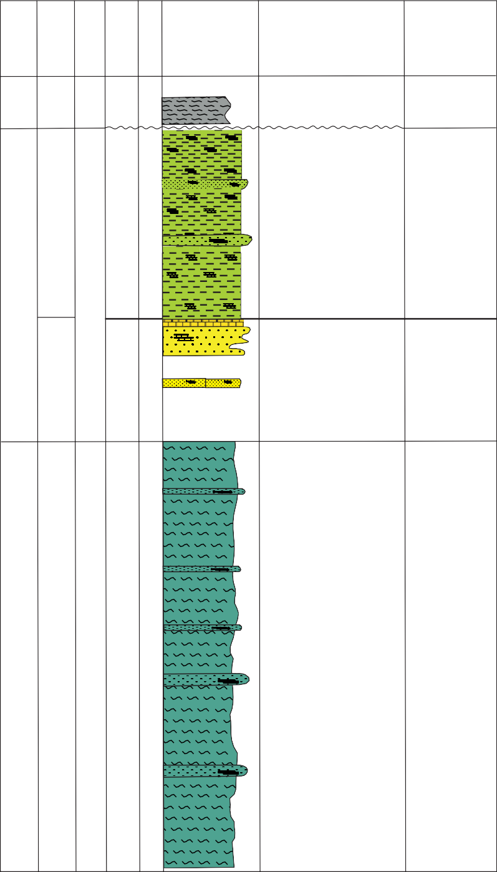
Figure 3. Stratigraphy of Kedungringin, Jombang, East Java.
Symbol of Lithology
Description of Lithology
Depositional Environment
Loose material from weathering and reworked of older rocks
Calcareous claystone Sonde, dominated by calcareous claystone with intercalation of calcareous sandstone, calcareous siltstone, massive and lamination stuctures.
Lagoon
Calcareous sandstone Sonde dominated by calcareous sandstone with intercalation of calcareous claystone, limestone, and calcareous siltstone.
Inner to Middle Shelf
Marl of Kalibeng, consisting of marl dominated, massive structure with intercalation of calcarenite limestone, calcareous sandstone, lamination and load cast sedimentary structures.
Inner to Middle Bathyal
Late Miocene to Late Pliocene
NN10-NN18
Kalibeng

Marl
446,3 m

Pleistocene
Holocene
Epoch
Martini (1971)
Formation
NN20-NN21
NN19-NN20
SSonde
Alluvium Lithology
Calcareous sandstone
47,5 m
Calcareous claystone
89,9 m
sediment

12 m
Unit
Thickness
IJOG
coaster asymmetricus, Discoaster blackstockae, Discoaster bolli, Discoaster brouweri, Dis- coaster calcaris, Discoaster druggii, Discoaster challengeri, Discoaster hamatus, Discoaster intercalaris, Discoaster neorectus, Discoaster perplexus, Discoaster pentaradiatus, Discoaster quadramus, Discoaster surculus, Discoaster

triradiatus, Discoaster tristellifer, Discoaster variabilis, Gephyrocapsa carribeanica, Ge- phyrocapsa oceanica, Helicosphaera carteri, Helicosphaera selli, Pseudoemiliania lacu- nosa, Pseudoemiliania ovata, Reticulofenestra haqii, Reticulofenestra minuta, Reticulofenestra minutula, Reticulofenestra pseudoumbilicus,

Table 1. Distribution of Nannofossils in Kalibeng River Section, Jombang Area
IJOG

FORMATION | UNIT OF LITHOLOGY | A G E | ZONE OF NANNOPLANKTON  ( Martini, 1971) |  | SPECIES OF CALCAREOUS NANNOFOSSIL
 |  |  |  |  | NUMBER OF SAMPLES | Calcidiscus leptoporus Ceratolithus acutus Coccolithus pelagicus Coccolithus pliopelagicus Discoaster altus Discoaster asymmetricus Discoaster berggrenii Discoaster blackstockae Discoaster bolli Discoaster brouweri Discoaster calcaris Discoaster chalengeri Discoaster druggii Discoaster hamatus Discoaster intercalaris Discoaster neorectus Discoaster pentaradiatus Discoaster perplexus Discoaster quadramus Discoaster quinqueramus Discoaster surculus Discoaster triradiatus Discoaster trisstellifer Discoaster variabilis Emiliania huxleyi  Gephyrocapsa caribbeanica Gephyrocapsa oceanica Helicosphaera carteri Helicosphaera granulata Helicosphaera selli .  Pseudoemiliania lacunosa  Pseudoemiliania ovata Reticulofenestra haqii Reticulofenestra minuta Reticulofenestra minutula Reticulofenestra pseudoumbilicus Reticulofenestra rotaria Rhabdosphaera clavigera Sphenolithus abies  Sphenolithus moriformis Sphenolithus neoabies
 |  |  | NN |  |  | 1 | 2 | 3 4 5 6 7 8 9 10 11 12 13 14 15 16 17 18 19 20 21 22 23 24 25 26 27 28 29 30 31 32 33 34 35 36 37 38 39 40 41
SONDE | Calc.Claystone | Early Pleistocene to Late Pleistocene | NN20-NN21 | 21 | D.33 | ● ● ● ─ ● ● ●
 |  |  |  |  | D.32 | ● ─ ● ● ● ●
 |  |  |  | 20 | D.31 | — ─  ● ─ ● ● ─ ─  ● ─ ─ ─ ● ● ● ● o
 |  |  |  |  | D.30
 |  |  |  |  | D.29
SONDE | Calc. Sandstone | Pliocene to Early Pleistocene | NN19-NN20 |  | D.28 | o ─ ─ ● ● ●
 |  |  |  | 19 | D.27  D.26 D.25 | ─ |  | — ─ ● ─  ● ─ ─ ● ─ ● ●  — o ─ ─ ─ ─ o ● o ─ ● ●
 |  |  |  | 18 | D.24 | ● ● ─ / ● ● ─ ─ / o
 |  |  |  | 17 | D.23 | — o ─ o ─ ● |  |  | ● ─ / ─ ● ● ● / ●
 |  |  |  | 16 | D.22 | ● ● ─ o ─ ─ ─ ─ ─ ● ─ o / ●  o ─ o ─ ● ─ ● ● ● ─ / o o /  ● o o ─ o ● ● ● ─ ● ─ ── ─ ● / o /  / / o o / ● o ● ● /
 |  |  |  |  | D.21
 |  |  |  |  | D.20
 |  |  |  |  | D.19
 |  |  |  |  | D.18 | ─ |  | o o o ● ● ● ─ ● ─ ● ● ● ● ● /
 |  |  |  |  | D.17 | ─ |  | ● ── ● / ● / ─ ● ─ ● ● ● ─ ● ● o ● / o /
 |  |  |  |  | D.16 | ─ |  | / / ─ / ● ● ● o ● / ● /
 |  |  |  |  | D.15 | ─ |  | / ─ ● ● ● ● ● ● ● ● ● ● ─ ● /
KALIBENG | Marl Unit | Miocene to | NN10-NN18 | 14- 15 | D.14 | / ● o ─ ─ ● / ● ● o  / ● ─ ─ ● ─ ─ ─ ● ● ● / ● o  — ─ ─ ●  o ● ─ ─ ● ● ─ ─ ● ● ●  — ● ─ ● / ●  ● ● ● ● ─ ─ ●
 |  |  |  |  | D.13
 |  |  |  |  | D.12
 |  |  |  |  | D.11
 |  |  |  |  | D.10
 |  |  |  |  | D.9
 |  |  |  | 13? | D.8 |  | ─ | o ─ ─ ● ● ─ ─ ─ ● ● ─ ─ ● ● ●  ● o ● ● o ─ ─  — ─ ● o ●
 |  |  |  |  | D.9
 |  |  |  |  | D.10
 |  |  |  | 12 | D.5 | — ─ ─ ● ─ ● ─ ─ o ● ─ ● o
 |  |  |  | 11 | D.4 | ─ |  | ● ● ─ ● ● ─ ●  ● ● ● ─ ● ─ ─ ● ─  ● ─ ─ ● ─ ─
 |  |  |  |  | D.3
 |  |  |  |  | D.2
 |  |  |  | 10 | D.1 | ● ─ ─ ─ ● ─ ─ ─ ─ o ─ ● ─ ─
Notes: / Abudance of Nannofossils species, o: Commond (6-10), ●: Frequent (2-5), ─ : Occasional (1)
Pliocene

Reticulofenestra rotaria, Rhabdosphaera clavig- era, Spenolithus moriformis, Spenolithus abies, Spenolithus neoabies, Syracosphaera sp., and Umbilicosphaera jafari.
The nannofossils recognized in Calcare- ous Sandstone Unit of Sonde Formation are
derived from sample D.25 to D.28 consisting of ten genera with forteen species; those are: Calcidiscus leptoporus, Coccolithus pelagicus, Coccolithus pliopelagicus, Discoaster triradia- tus, Gephyrocapsa carribeanica, Gephyrocapsa oceanica, Helicosphaera carteri, Helicosphaera

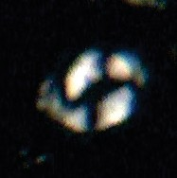
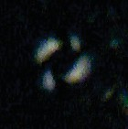
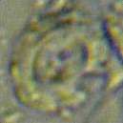
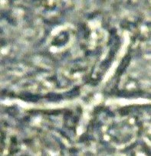
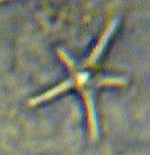
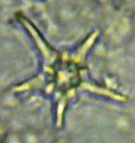
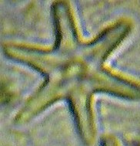
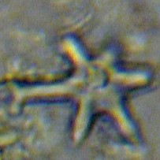
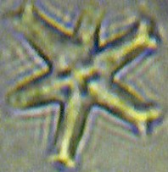
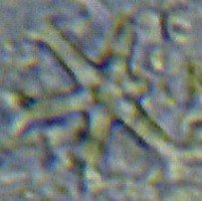
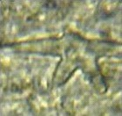
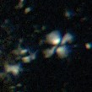
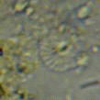
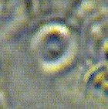
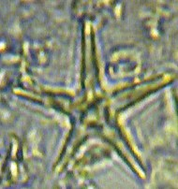
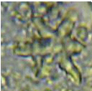
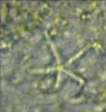
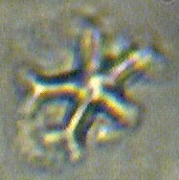
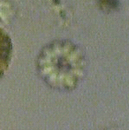
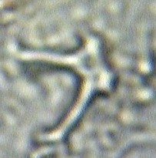
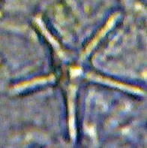
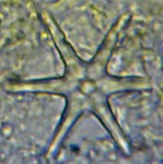
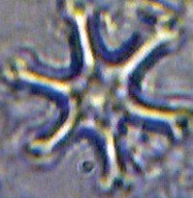
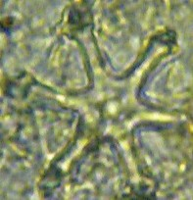
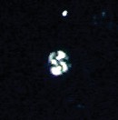
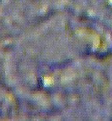
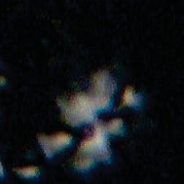
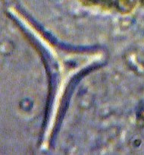
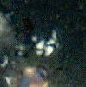
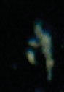
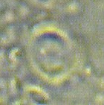
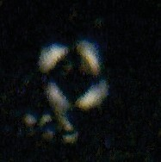
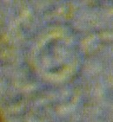
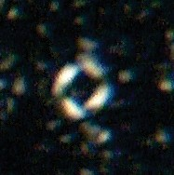
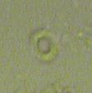
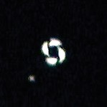
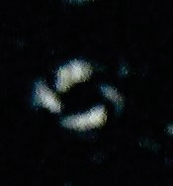
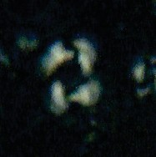
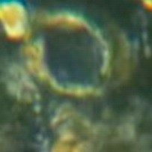
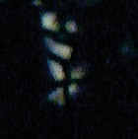
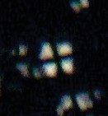
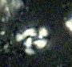
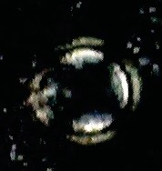
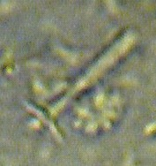
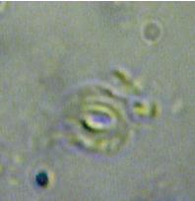
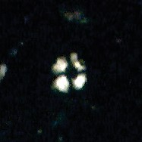
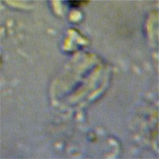
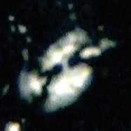
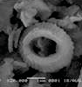
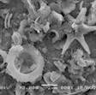
Calcidiscusleptoporus (// Nicol, 6 µm)
Calcidiscusleptoporus
(X Nicol, 6 µm) (// Nicol, 13 µm) (X Nicol, 13 µm) (// Nicol, 12 µm) (X Nico,l12 µm)
Coccolithus pelagicus
Coccolithus pelagicus Coccolithus pliopelagicus Coccolithus pliopelagicus
Discoasteraltus
(// Nicol)
Discoaster blackstockae Discoaster asymmetricus Discoaster asymmetricus Discoaster berggrenii
(// Nicol )
(// Nicol)
(// Nicol)
(X Nicol)
Discoaster bolli
(// Nicol)
Discoaster brouweri
(// Nicol)
Discoaster calcaris Discoaster challengeri Discoasterdruggi Discoasterhamatus
(// Nicol)
(// Nicol)
(// Nicol)
(// Nicol)
Discoaster intercalaris
(// Nicol)
Discoaster pentaradiatus (// Nicol)
Discoaster perplexus
(// Nicol)
Discoaster quadramus Discoaster quinqueramus Discoaster triradiatus
(// Nicol)
(// Nicol)
(// Nicol)
Discoaster tristellifer (// Nicol)
Discoaster variabilis (X Nicol)
Discoaster surculus (X Nicol)
Gephyrocapsa caribbeanica Gephyrocapsa oceanica Helicosphaera carteri
(X Nicol , 4-5 µm) ( X Nikol, 3.5 to 6)
(// Nicol)
Helicosphaera carteri (X Nicol)
Helicosphaera granulata (X Nicol)
Ceratolithus acutus (X Nicol)
Pseudoemiliania lacunosa Pseudoemiliania lacunosae Pseudoemiliania ovata
(// Nicol, >4µm) (X Nicol, >4µm) ( // Nicol, 3-4µm)
Pseudoemiliania ovata ( X Nicol 3-4µm)
Reticulofenestra pseudoumbilica (X Nicol, and // Nicol,, 6 µm)
Reticulofenestra minuta Reticulofenestra minuta Reticulofenestra minutula Reticulofenestra pseudoumbilica
(// Nicol <3μm)
(X Nicol, 3 µm) (X Nicol 3-5 µm)
(X Nicol, 7 µm)
Reticulofenestra rotaria Rhabdospaera clavigera Scyphosphaera globulata Sphenolithus abies
(X Nicol)
(// Nikol)
(?? Nicol)
(X Nicol, 3 -4 µm) (X Nicol, 3 -7 µm (X Nicol, 2 -3 µm)
Sphenolithus moriformis
Sphenolithus neoabies
Syracopsphaera sp. Umbilicospaera jafari (XNikol) (X nikol)
Helicosphaera selli (// Nicol, X Nicol,12 µm)
Reticulofenestra 1µm dg SEM
Discoaster brouweri 2µm dg SEM
IJOG

Figure 4. Photomicrographs of nannofossil species (1000x) in the researched area.

selli, Pseudoemiliania lacunosa, Pseudoemiliania ovata, Reticulofenestra minuta, Rhabdosphaera clavigera, Syracosphaera sp., and Umbilico- sphaera jafari.
The nannofossils found in Calcareous Clay- stone Unit of Sonde Formation derived from sample D.29 to D.33 consist of eight genera with eleven species (Table 1), such as: Calcidiscus leptoporus, Coccolithus pelagicus, Coccolithus pliopelagicus, Discoaster triradiatus, Gephy- rocapsa carribeanica, Gephyrocapsa oceanica, Helicosphaera carteri, Helicosphaera kamptnari, Reticulofenestra minuta, Rhabdosphaera clavig- era, and Syracosphaera sp.
The occurrence result of twelve genera and forty-three species indicates that the age of Marl Unit of Kalibeng is NN10-NN18, Calcareous Sandstone Unit of Sonde is NN19, and Calcare- ous Claystone Unit of Sonde is NN20-NN21, according to the classification of Martini (1971). The index fossil used to indicate age in this research is the first and t h e last appearance of species Ceratolithus acutus, Discoaster asym- metricus, Pseudoemiliana lacunose, Discoaster
IJOG
surculus, and Sephyrocopsa oceanica.

Discussion

The studied area belongs to the type locality of the Kalibeng Formation in Kendeng Zone, with the order of stratigraphy from older to younger consists of Marl Unit of Kalibeng Formation,

Calcareous Sandstone Unit, and Calcareous Claystone Unit of Sonde Formation (Figure 3).
Result of the previous study carried out by Choiriah (2001) in Bengawan Solo River of Ngawi Section, shows the presence of nineteen genera and fifty-two species. Kalibeng Formation contains eighteen genera and forty-nine species, while Klitik and Sonde Formations have eight genera and twelve species. Kalibeng Formation is of Late Miocene to Late Pliocene (NN12-NN18) in age while, Klitik (Sonde) Formation is of Pleistocene (NN19-NN20) (Table 2).
Results of the study from Kalibeng River Sec-
tion of Kedungringin, Plandaan Area, Jombang, indicate the occurrence of twelve genera and forty-three species. Kalibeng Formation (Marl Unit) containing twelve genera and thirty-nine species, sends to indicate that the age of this formation ranges from Middle Miocene to Late Pliocen (NN10 to NN18).
While Sonde Formation (Calcareous Sand- stone Unit) is of Pleistocene (NN19) and Cal- careous Claystone Unit of Klitik Formation is Pleistocene (NN20 to NN21) in age (Table 2 and Figure 5).
The results of the study show the differences in age, especially for the Sonde/Klitik Formation. Based on the nannofossil analysis, the Klitik/ Sonde Formation is of Pleistocene, which is younger than the age based on the foraminifera analysis (Pliocene). The correlation of the same formation based on foraminifera biostratigraphy with nannofossil is shown in Figure 5.

Table 2. Correlation of Nannofossil Distribution and The Age of Unit/Formation
Kalibeng River, Kedungringin Section, Jombang, 12 Genus and 43 species Unit/Formation Genus Species Age
Calcareous Claystone Unit Sonde 8 11 NN20-N21 (Pleistocene) Calcareous Sandstone Unit Sonde 10 14 NN19 (Pleistocene)
Marl Unit of Kalibeng 12 39 NN10-NN18 (Late Miocene-Late Pliocene)
Bengawan Solo River, Ngawi Section, 19 Genus and 52 Species Unit/Formation Genus Species Age
Limestone Unit of Klitik/Sonde 8 12 NN19-NN20 (Pleistocene) Marl Unit of Kalibeng 18 49 NN12-NN18 (Pliocene)

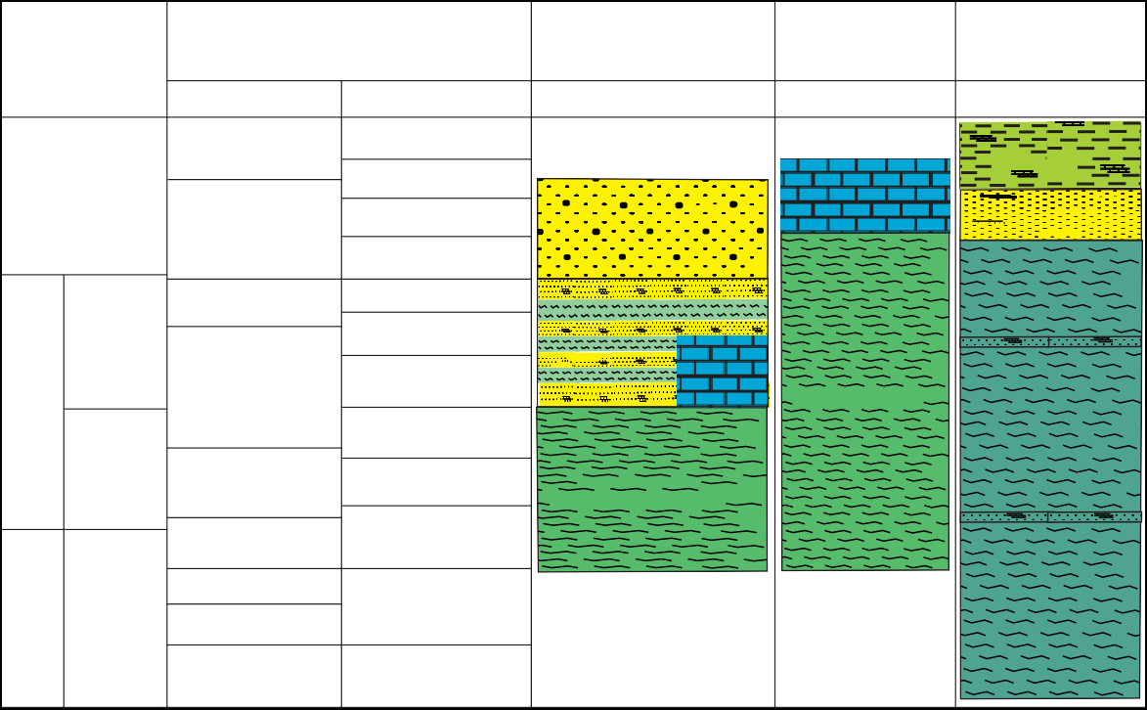
Notes: Regional stratigraphy of Kendeng Zone (Pringgoprawiro, 1983) is prepared based on foraminifera from several regions, especially the location of the formation type.
AGE
BIOSTRATIGRAPHIC CORRELATION CHART
FORAMINIFERA
N23
PLEISTOCENE
N22
N20
NANNOFOSSIL NN.21 NN.20 NN.19 NN.18
NN.17 NN.16
NN.15 NN.14 NN.13
NN.12
Pringgoprawiro, 1983 Strat. Kendeng Zone
Foraminifera
Choiriah, 2001 Ngawi Section
Nannofossil
Pucangan
Klitik
Choiriah, 2019 Jombang Section
Nannofossil
Sonde
Sonde
N21
LATE

Sonde Klitik
Kalibeng
Kalibeng
EARLY
Kalibeng
LATE
N19
N18
N17 N16
N15
NN.11
MIOCENE
PLIOCENE
IJOG

Figure 5. Age differences of Kalibeng, Klitik, and Sonde Formations of the Kendeng Zone based on foraminifera (Pring- goprawiro, 1983) and nannofossil (Choiriah, 2001).

Conclusion and Recomendation

The analysis results conducted during this study identify the presence of twelve genera and forty-three species, showing this section has abundant nannofossils. The age of Marl Unit of Kalibeng Formation is NN10-NN18 (Middle Miocene to Pliocene), Calcareous Sandstone Unit of Sonde Formation is NN19-NN20 (Pleisto- cene), while the age of Calcareous Claystone Unit of Klitik Formation is NN20-NN21 (Pleistocene). The distribution of nannofosil in the Kalibeng River, Jombang, indicates fewer genera and spe- cies than that of Bengawan Solo River, Ngawi. Kalibeng River, Jombang, has twelve genera and forty-three species, while the Bengawan Solo River, Ngawi Section, has nineteen genera and
fifty-two species.
The correlation results show that the age of Kalibeng Formation in Jombang is older, indicating NN10−NN18 (Middle Miocene to Late Pliocene) compared to the Kalibeng Formation in

Ngawi which is NN12 to NN18 (or Late Miocene to Late Pliocene).
Sonde Formation (Calcareous Sandstone Unit and Calcareous Claystone Unit) in Jombang is younger than Klitik/Sonde Formation in Ngawi. Sonde Formation in Jombang indicates NN19− NN21 (Pleistocene), while that in Ngawi shows NN19 to NN20 (Pleistocene).

Acknowledgements

The authors would like to thank Kemenristek Dikti for the PUPT research foundation; Dr. Ir. Sutarto, M.T. and Purwanto, S.H. for facilitating the nannofossil analysis in Petrographic Labora- tory; Ir. Bambang Triwibowo, M.T. for helping to review the paper; Debby Yulfira, S.T. for helping the fossil analysis, and the chair of Geological Engineering Department, Faculty of Mineral Technology, UPN “Veteran” Yogyakarta, for the support to authors research. The authors’ would

also like to thank all reviewers for their useful suggestions to authors’ work.

References

Aubry, M-P., 1985. Northwestern European Pa- leogene magnetostratigraphy, biostratigraphy and paleogeography: calcareous nannofosil evidence. Geology, 13 (3), p.198-202.
Berghuis, H.W.K., Troelstra, S.R., and Zaim, Y., 2019. Biostratigraphy of the Eastern Kendeng Zone (Java, Indonesia): The Marmoyo and Sumberingin Sections. Journal of Palaeogeog- raphy, Palaeoclimatology, Palaeoecology, 528, p. 218-231. DOI: 10.1016/j.palaeo.2019.05.008
IJOG
Choiriah, S.U., Kapid, R., and Rahardjo, W., 2001. The Pliocene/Pleistocene Boundary, Based On Calcareous Nannofossils, And Related Palaeoclimatic Implications, Solo River Section, Ngawi Region, East Java, In- donesia. Journal of Nannoplankton Research London,.23,1, p.15-19. URL: ina.tmsoc.org/ JNR/online/23/Choiriah%2 20et%20al%20 2001%20JNR%20231.pdf.
Lunt, P., 2019. The origin of the East Java Sea basins deduced from sequence stratigraphy. Journal of Marine and Petroleum Geol- ogy, 105, p. 17-31. DOI: 10.1016/j.marpet-
geo.2019.03.0 38.

Martini, E., 1971. Standard Tertiary and Quater- nary calcareous Nannoplankton biozonation. In: Bilal, U.H., 1984 (ed.), Nannofossils Bio- stratigraphy Part III:12., Cenozoic Biostratig- raphy, Hutchinson Ross Publishing Company, Stroudsburg, Pensylvanian. p.264-307.
Okada, H. and Bukry, D., 1980. Supplementary Modification and Introuction of Code Number to the Low-Latitude Coccolith Biostrati- graphic Zonation (Bukry, 1973; 1975).
Marine Micropaleontology, 5 (3), p.321-325. DOI:10.1016/0377-8398(80)90016-x
Perch-Nielsen, K. and Nielsen., 1985. Ceno- zoic calcareous nannoplankton, Chapter 10. In: Bolli, H.M., Saunders, J.B., and Perch- Nielsen, K. (eds.), Plankton Stratigraphy, Cambridge Earth Science Series, Cam- bridge Univ. Press, Cambridge, p.427-554. DOI:10.1017/s0016756800035214
Pringgoprawiro, H., 1983. Biostratigrafi dan palaeogeografi Cekungan Jawa Timur Utara pendekatan baru, Disertasi Doktor Teknik Geologi, ITB, 239pp.
Van Gorsel, J.T., Lunt, P., and Morley, R., 2014. Introduction to Cenozoic biostratigraphy of Indonesia, SE Asia, Biostratigraphy of Southeast Asia Part 1. Indonesian Journal of Sedimentary Geology, 29 (4) p.6-40.

